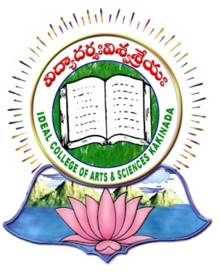 | IDEAL COLLEGE OF ARTS AND SCIENCES (A)
 | (A.P. Govt., Aided., Autonomous & NAAC B++)
 | Dr. P.V.N. RAJU VIDYAPRANGANAM
Samalkot Road, KAKINADA
East Godavari Dist
Andhra Pradesh

Department of Computer Science

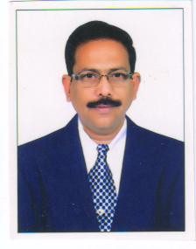

Profile

- Name : Mohammad Abdul Sayeed
- Designation and Place of work : Lecturer in Computer Science
Ideal College of Arts & Sciences (A)
Kakinada-533003
A.P., INDIA.
- Date of Birth : 25-05-1963
- Nationality : Indian
- Mobile no : 9603172801
- E-mail : mabdulsayeedshajahan@gmail.com
- Address for Correspondence :
Associate Professor in Computer Science,
Ideal College of Arts & Sciences,
Kakinada – 533 003, A.P., India.

- Details of Educational Qualifications:
Sl. No. | Course | University | Year | Specialization
1 | M.Sc., | Andhra University | 1984-86 | Applied Mathematics
2 | P.GDCA | JNTU KAKINADA | 1988-1989 | Computer Applications
3 | M.Tech. | JNTU KAKINADA | 2007-2009 | Computer Science & Engineering

- Experience:

Sl.No | Designation | College | Date of Joining | Experience
1 | Lecturer in Computer Science | Ideal College of Arts & Sciences | 15-3-1989 | 28

- Regional/ State/National level Conferences/Workshops/Seminars

- International Conference on “Emerging Trends in Computer Science, Communication and Information Technology” From 9th to 11th January, 2010 Organized By Department of Computer Science & I.T. Yashwant Mahavidyalaya College, Nanded, Maharastra State. Poster presented on TCP-LP: Low-Priority service via End-Point congestion control.
- National Conference on Information Technology Enabled Services (NCOITES-2010) 22nd & 23rd October, 2010 organized by Department of Computer Science, Adikavi Nannaya University, Rajahmundry, Andhra Pradesh.
Paper presented on IEEE 802.11e(QOS) Throughput Guarantees in Wireless Networks.
- National Seminar on “Advanced Trends in Mobile Comuting” 5th and 6th February, 2010 NSATMC 2010 Under Quality Improvement Program of University of Pune organized by Department of Computer Science, Progressive Education Society’s, Modern College of Arts, Science and Commerce, Ganeshkhind, Pune.
- National Seminar on “Recent Trends in Information and Communication Technology” RTICT January 7-9, 2012 organized by Department of Computer Science, Krishna University, Machilipatnam, Andhra Pradesh, India under the aegis of Andhra Pradesh State Council of Higher Education, Hyderabad and Indian Space Research Organization, Bangalore.
Paper presented on “Security Issues Using Dynamic Source Routing and RIP in Adhoc Wireless Networks.”
- National Conference on “Advanced Techniques in Computer Science (NCATCS-2K12) Sponsored by UGC February 24th-25th, 2012 organized by Department of Computer Science, Ideal College of Arts & Sciences (A), Kakinada, Andhra Pradesh.
Paper presented on “Quality of Service Issues in IEEE 802.11e Wireless LANs”
Paper presented on “Soft Computing and Decision Making Techniques”
Paper presented on “Green Computing: A Case Study of Ideal College of Arts & Sciences (A), Kakinada, A.P., India.”

- Administrative Experience: 28 Years

- Training Programs/ Courses attended:
Infosys Project Genesis Program:
Actively participated for Infosys Project Genesis Program for period of 15 days and Team Leader for my group and presented Papers on MIND MAPPING and Nominated as Mentor for Analytical Skills to train to the Students.
UGC-Sponsored Refresher course at Andhra University:
Participated in UGC-Sponsored Refresher course (Period of 20 Days) in the subject Computer Science, UGC-Academic Staff College, Andhra University, Visakhapatnam
Participated in Workshop on “LOW-POWER VLSI DESIGN & TECHNOLOGY” USIC Andhra Pradesh, Visakhapatnam.

